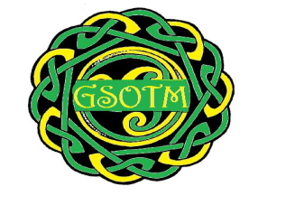GLENGORMLEY SCHOOL OF TRADITIONAL MUSIC
Motions/Recommendations

I ________________________ would like to make the following motion/recommendation (delete as applicable)
______________________________________________________________________________________________________________________________________________________________________________________________________________________________________________________________________________________________________________________________________________________________________________________________________________________________________________________________________________________________________________________________________________________________________________________________________________________________________________________________

Please return motions/recommendations forms to the addresses below before Thursday 22 November 2018.
Vaun McCallan, 31 Hollybrook Manor, Newtownabbey BT36 7XR
OR
Vaunmccallan@hotmail.com

