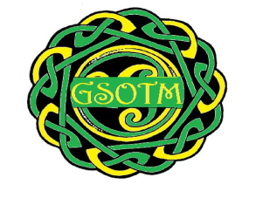GLENGORMLEY SCHOOL OF TRADITIONAL MUSIC
Nomination Form
I _________________________ would like to nominate the following person/people for the following position(s)
Chairman ________________________________________
Vice Chairman ________________________________________
Secretary ________________________________________
Treasurer ________________________________________
Musical Director ________________________________________
Committee Member ________________________________________
________________________________________
________________________________________
I have asked the above nominee(s) about their nominations and they are willing to stand for the above position(s)

Signature _____________________ Date ________________________
Please return nomination forms to the address below before Thursday 21st November 2018.
Vaun McCallan, 31 Hollybrook Manor, Newtownabbey BT36 7XR
Or
Vaunmccallan@hotmail.com

